

Course Name: Embedded Systems Design

Section 1

Lab Report 1

Submitted to faculty: [Anurag Lakhlani](mailto:anurag.lakhlani@ahduni.edu.in)

Date of Submission: 22nd September 2021

Student Details

| Roll No. | Name of the Student | Name of the Program |
| --- | --- | --- |
| AU1940049 | Sameep Vani | BTech CSE |

**Experiment 1**

Experiment Set-up:

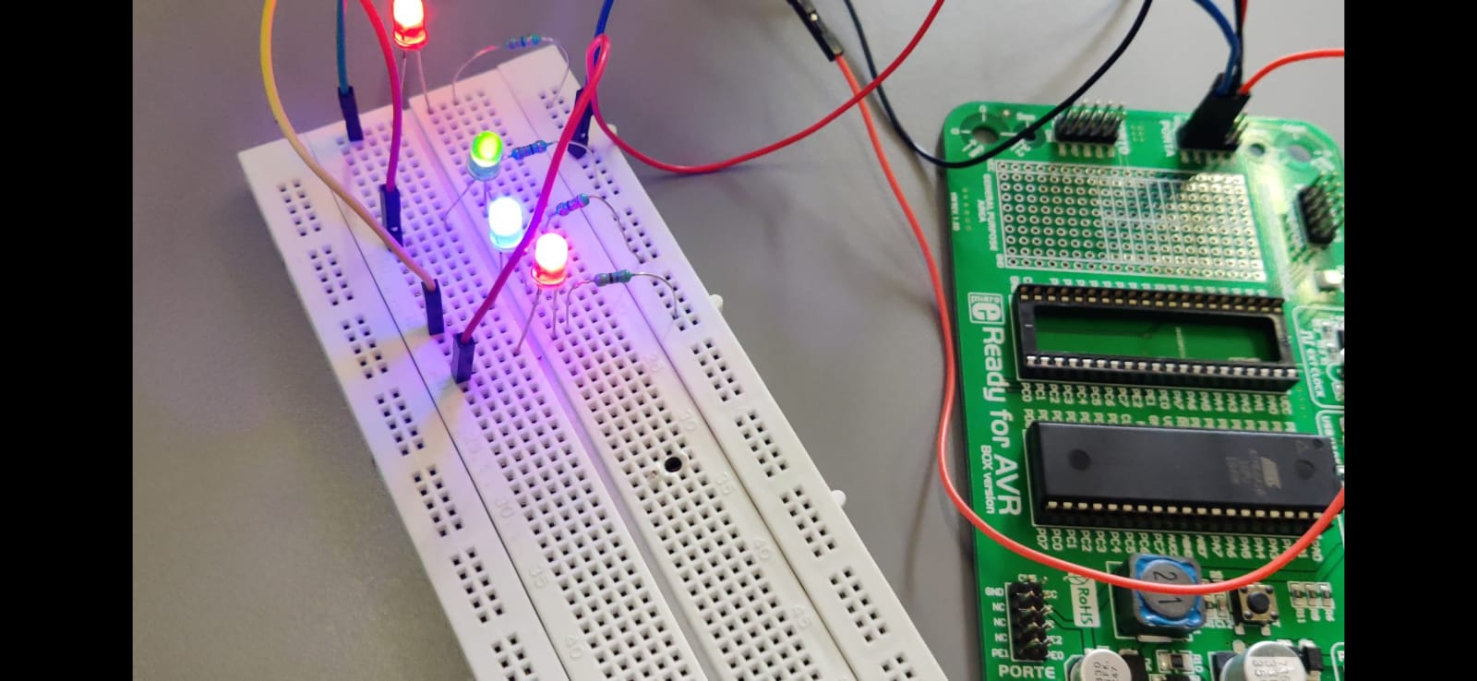

Description:

The experiment was about turning LEDs on PORTA from Pins 4 to 7 and at PORTB pins 0,2,4,6. For this we find the hex number for PORTA pins 4 to 7 which is 0xF0. Thus, we define these pins as output pins. Similar is the case for PORTB pins 0,2,4,6 and the hex number that we get is 0x55. Connections are quite simple. Having connected the Vcc and ground at appropriate places, we connect a resistor to the ground and LED and that LED is connected to the required output ports. In this way, there is a potential drop across the resistor and the LED remains safe. Note here that the for loop is just for providing some delay.

Video: [Link](https://drive.google.com/file/d/1b_LVe3k9jLIlHvcoQm2vr-SI2otUQ13h/view)

Code:

void main() {

int i;

DDRA = 0xF0; // Define the required output pins

DDRB = 0x55;

while(1) { // Continuous Loop

PORTA = 0xF0; // Turn required pins on

PORTB = 0x55;

for(i = 0;i<50000;i++) {} // Providing Delay

PORTA = 0x00; // Turn all pins off

PORTB = 0x00;

for(i = 0;i<50000;i++) {}

}

}

Circuit Diagram:

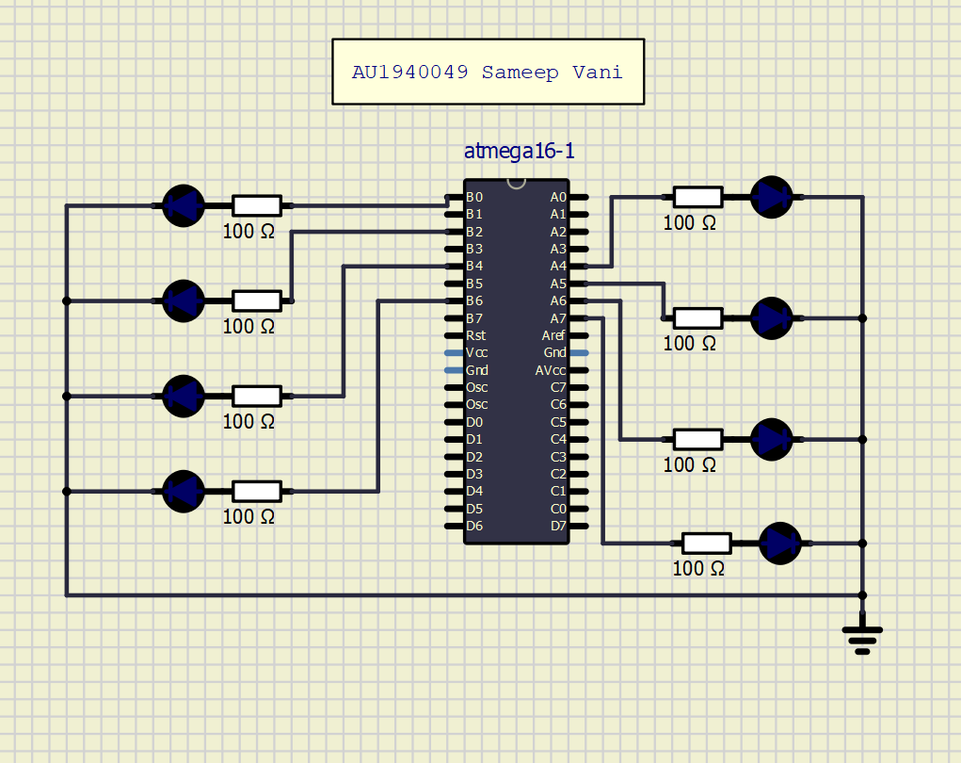

**Experiment 2**

Experiment Set-up:

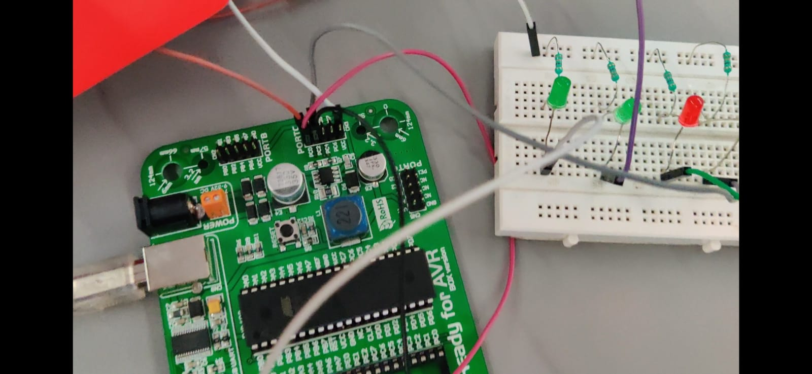

Description:

The key aspect of this experiment was using software delay to make the LED blinking. The connections are more or less similar to the first experiment except for the fact that everything now had to be moved to PORTC. Furthermore, the pins are now 0-3 of PORTC. Thus, the hex number, in this case, becomes 0x0F. Note that delay, in this case, is provided using software inbuilt functions.

Video: [Link](https://drive.google.com/file/d/1f7RAfSGb7eSTraydiXxQ9VeDvQgblA_n/view?usp=sharing)

Code:

void main() {

int i;

DDRC = 0x0F; // Define the required output pins

while(1) // Continuous Loop

{

PORTC = 0X00; // Turn required pins off

Delay_ms(100) // Providing delay of 100ms

PORTC = 0X0F; // Turn required pins on

Delay_ms(100)

}

}

Circuit Diagram:

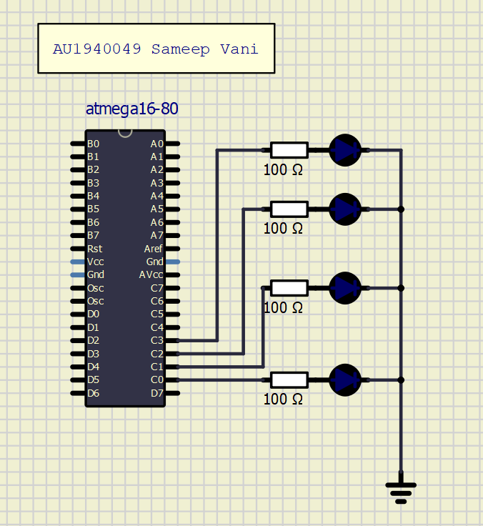

**Experiment 3**

Experiment Set-up:

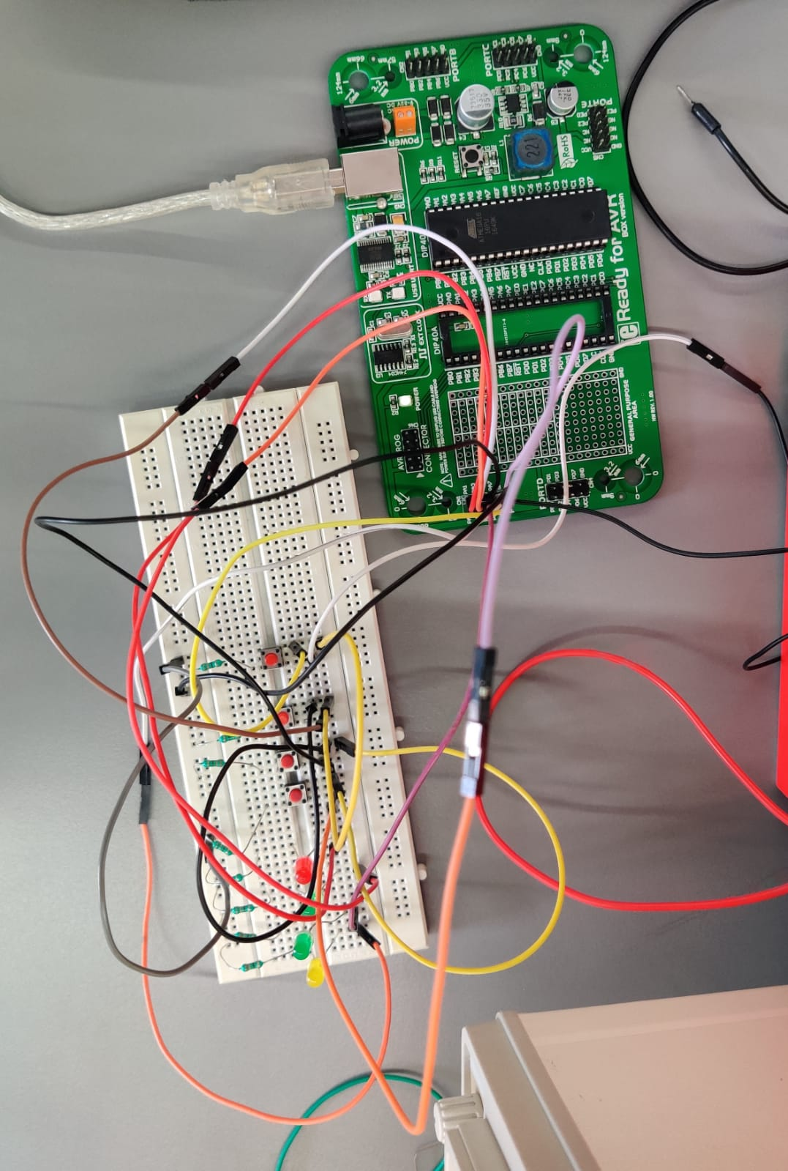

Description:

The experiment includes a new aspect of a switch. For this experiment, we had to display the output of PORTA pins 1,3,5,7 and display that at pins 0,2,4,6 of PORTA respectively. So in short, if we press the switch connected to pin 1, then the LED connected to pin 0 should light up. The construction of the switch is such that the pins along the width of the switch are internally connected and when it is pressed, the diagonal ends are connected causing a potential difference. Note that in the following experiment we require two resistors. One is the usual resistor connected between LED and ground and the other being the resistor connected to the ground and the switch. The primary reason for this is to get a potential difference otherwise the LED won’t light up because the current won’t be flowing.

Video: [Link](https://drive.google.com/file/d/1-t06tyFQ0VGzP2EeOWOxA-8W7A5Ldj_T)

Code:

void main() {

int i;

DDRA = 0x55; // Define the required output pins

while(1) // Continuous Loop

{

if(PINA.b1 == 1) // Set condition if first pin of PortA is 1

{

PORTA.b0 = 1;// Turn on pin0 of PortA

}

if(PINA.b3 == 1)

{

PORTA.b2 = 1;

}

if(PINA.b5 == 1)

{

PORTA.b4 = 1;

}

if(PINA.b7 == 1)

{

PORTA.b6 = 1;

}

}

Circuit Diagram:

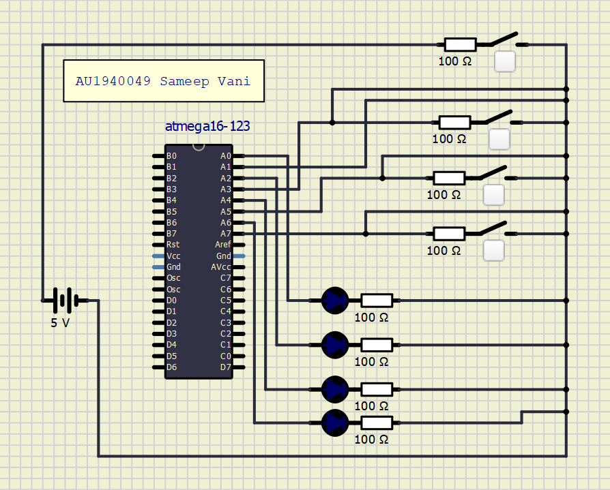

**Experiment 4**

Experiment Set-up:

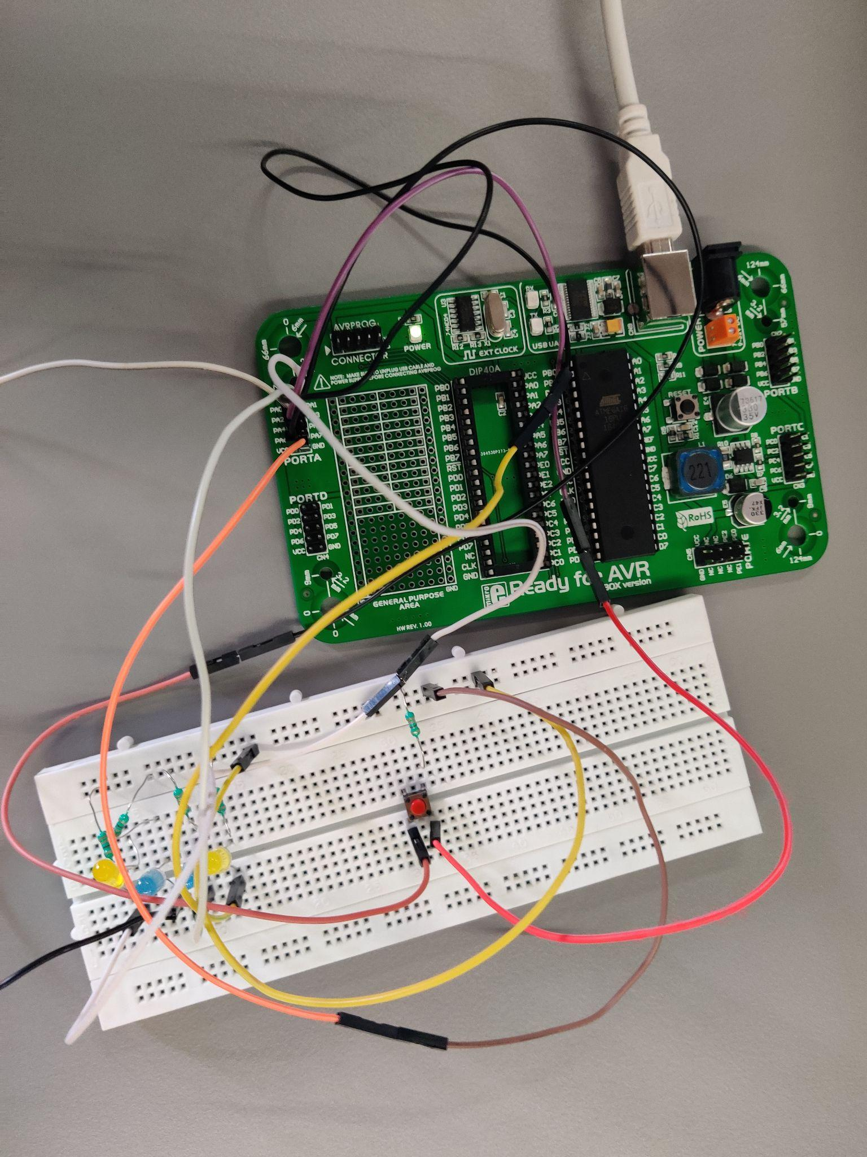

Description:

In this experiment, we had to count 1 to 15 (in binary) using switches and LED’s with a delay of 1 second between every count. Furthermore, we should start from the beginning once we reach 15 or we turn off the switch. For this to achieve, continuously run the for loop using the while loop. As for the second condition, place an if condition for the switch. In my case, the switch was connected at pin 4 of PORTA and inside that reset the counter and break the loop.

Video: [Link](https://drive.google.com/file/d/1GiSXm_6VCHWlcn3yDEADXmYqjO_wuNj2/view?usp=sharing)

Code:

int i;

void main() {

DDRA = 0x0F;

while(1)

{

if(PINA.b4 == 1)

{

for(i=0;i<=15;i++)

{

PORTA = i;

if(PINA.b4 == 0)

{

i=0;

break;

}

}

}

}

}

Circuit Diagram:

